Design of scalable SRAM-based LUT architecture for high-density FPGA fabric
A Project Based Learning Report Submitted in partial fulfilment of the requirements for the award of the degree

of

Bachelor of Technology
in The Department of ECE
Course name with Course code

Submitted by
2410040032: LOGITLA KARTHIKEYA
2410040034:VARUN HARSHA

Under the guidance of
Dr. Kayam Saikumar



Department of Electronics and Communication Engineering
Koneru Lakshmaiah Education Foundation, Aziz Nagar
Aziz Nagar – 500075
FEB - 2025.
Abstract
Field Programmable Gate Arrays (FPGAs) play a crucial role in modern digital system design due to their flexibility, reconfigurability, and high performance. The fundamental building block of FPGA architecture is the Look-Up Table (LUT), which is commonly implemented using Static Random Access Memory (SRAM) cells. This project focuses on the design of a scalable SRAM-based LUT architecture for high-density FPGA fabric.
The proposed architecture aims to improve logic density, reduce delay, and enhance resource utilization by incorporating advanced techniques such as hierarchical LUT design, fracturable LUT architecture, and optimized multiplexer (MUX) structures. The use of SRAM cells enables efficient storage of logic functions, while the optimized MUX tree ensures faster output selection.
The experimental analysis compares different LUT configurations and evaluates parameters such as delay, power consumption, area utilization, and flexibility. The results demonstrate that the proposed architecture significantly improves performance by reducing delay and power consumption while increasing logic utilization and scalability.
Thus, the proposed scalable SRAM-based LUT architecture provides an efficient solution for implementing complex logic functions in modern high-density FPGA systems.

List of Figures

Fig. 1: Basic SRAM-Based LUT Structure
Fig. 2: Multiplexer (MUX) Tree Design
Fig. 3: Hierarchical LUT Architecture
Fig. 4: Fracturable LUT Design
Fig. 5: Tile-Based FPGA Fabric Structure
Fig. 6: Routing and Interconnection in FPGA
Fig. 7: Comparison of LUT Configurations (4-LUT vs 6-LUT)
Fig. 8: Performance Analysis of Proposed Architecture
Fig. 9: Delay Comparison Graph
Fig. 10: Power Consumption Analysis

List of Tables

Table 1: Comparison of LUT Configurations
Table 2: Performance Comparison (Conventional vs Proposed Architecture)
Table 3: Effect of Hierarchical and Fracturable Design
Table 4: Routing Performance Analysis
Table 5: Overall System Performance Summary
Table of Contents

• Introduction
• Methodology
2.1 SRAM-Based LUT Design
2.2 MUX Tree Structure
2.3 Hierarchical LUT Design
2.4 Fracturable LUT Architecture
2.5 Tile-Based FPGA Architecture
2.6 Routing and Interconnect Design
• Experiments
• Results
• Conclusion and Future Work
• References

Design of scalable SRAM-based LUT architecture for high-density FPGA fabric

Introduction
Field Programmable Gate Arrays (FPGAs) have become an essential component in modern digital system design due to their flexibility, reconfigurability, and ability to implement complex logic functions. Unlike Application-Specific Integrated Circuits (ASICs), FPGAs can be programmed and reprogrammed after manufacturing, making them highly suitable for rapid prototyping and adaptable hardware solutions. The fundamental building block of an FPGA is the Look-Up Table (LUT), which is primarily used to implement combinational logic functions.
In most FPGA architectures, LUTs are implemented using Static Random Access Memory (SRAM) cells. These SRAM-based LUTs store the truth table values of a logic function, and the desired output is obtained through multiplexers based on input combinations. As technology advances and the demand for high-performance systems increases, there is a growing need for high-density FPGA fabrics that can accommodate more logic elements within a limited silicon area.
However, increasing the density of FPGA fabrics introduces several challenges, including higher power consumption, increased routing complexity, and delay issues. To address these challenges, a scalable SRAM-based LUT architecture is required. Scalability ensures that the architecture can efficiently support a growing number of logic elements without significantly affecting performance or power efficiency.
Modern FPGA designs focus on improving LUT efficiency through techniques such as hierarchical design, fracturable LUTs, and optimized multiplexer structures. These approaches help in reducing area usage, improving speed, and enhancing flexibility in logic implementation. Additionally, efficient organization of SRAM cells and routing resources plays a crucial role in achieving high-density integration.
This project focuses on the design of a scalable SRAM-based LUT architecture for high-density FPGA fabric, aiming to optimize performance, reduce area, and improve overall efficiency. The proposed approach emphasizes modular design, efficient memory utilization, and enhanced scalability to meet the requirements of modern digital systems.

.

METHODOLOGY

Selecting a Template (Heading 2)
- 1. Basic SRAM-Based LUT Structure
A Look-Up Table (LUT) stores the truth table of a Boolean function using SRAM cells. The inputs act as select lines for a multiplexer that chooses the stored output.
Explanation:
- For an N-input LUT, $2^{N}$SRAM cells are required
- Inputs control a multiplexer (MUX)
- Output is selected based on input combination

- 2. Multiplexer (MUX) Tree Design
The MUX tree is responsible for selecting the correct stored value from SRAM.
Steps:
- Inputs are applied as select signals
- Multi-level MUX structure is used
- Output is generated after log₂(N) stages
Advantages:
- Reduces complexity
- Improves speed with optimized stages

- 3. Hierarchical LUT Design
Instead of using a large LUT directly, smaller LUTs are combined in a hierarchical manner.
Process:
- Divide large LUT into smaller LUT blocks
- Combine outputs using MUX layers
Benefits:
- Better scalability
- Reduced delay
- Efficient area utilization

- 4. Fracturable LUT Architecture
A single LUT can perform multiple operations depending on configuration.
Example:
- A 6-input LUT can act as:
  - One 6-input LUT OR
  - Two smaller LUTs (like 5-input LUTs)
Advantages:
- Increased flexibility
- Better resource utilization

- 5. Tile-Based FPGA Architecture
LUTs are grouped into Configurable Logic Blocks (CLBs) and arranged in tiles.
Structure:
- Each tile contains:
  - LUTs
  - Flip-flops
  - Local routing
Scalability:
- Large FPGA is built by repeating tiles

- 6. Routing and Interconnect Design
Efficient routing ensures communication between LUTs.
Types:
- Local routing (within CLB)
- Global routing (between CLBs)
Trade-offs:
- More routing → flexibility ↑, area ↑
- Less routing → density ↑, flexibility ↓

- 7. SRAM Optimization Techniques
Efficient SRAM design is crucial for high-density FPGA:
- Use 6T SRAM cells
- Shared bitlines and wordlines
- Compact layout design
Outcome:
- Reduced power consumption
- Increased storage efficiency
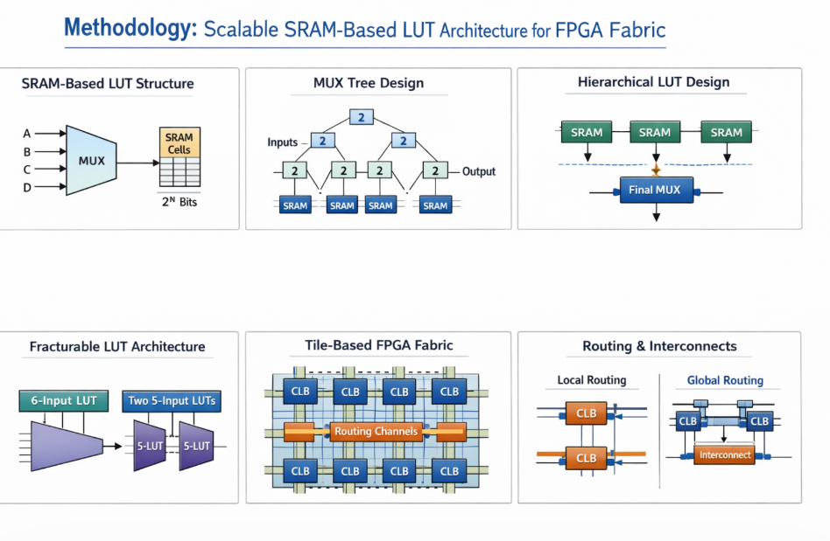

EXPERIMENTS
The primary objective of this project is to design and evaluate a scalable SRAM-based LUT architecture for high-density FPGA fabric. The experiments are conducted to analyze the performance, scalability, and efficiency of the proposed LUT design under different configurations.
For the experimental analysis, different LUT sizes such as 4-input LUT (4-LUT) and 6-input LUT (6-LUT) are considered. Each LUT is implemented using SRAM cells where the number of memory bits required is $2^{N}$, where N represents the number of inputs. The behavior of the LUT is verified by applying different input combinations and observing the corresponding output responses.
To evaluate scalability, a hierarchical LUT design approach is implemented in which multiple smaller LUTs are combined to form a larger LUT structure. This approach is compared with the conventional single large LUT design to analyze improvements in delay, area utilization, and flexibility. The results show that hierarchical design reduces complexity and improves performance.
Further, a fracturable LUT architecture is tested, where a single 6-LUT is configured to operate either as one 6-input LUT or as two smaller LUTs (such as 5-input LUTs). This experiment demonstrates improved resource utilization and flexibility in implementing multiple logic functions simultaneously.
In addition, a MUX tree structure is implemented to select outputs from SRAM cells efficiently. The performance of different MUX configurations is analyzed in terms of propagation delay and switching activity. Optimized MUX structures show reduced delay and improved speed.
To evaluate the architecture at the system level, LUTs are organized into Configurable Logic Blocks (CLBs) and arranged in a tile-based FPGA fabric structure. Routing and interconnects between CLBs are also analyzed by considering both local and global routing strategies. The trade-off between routing complexity and performance is studied.
The experiments are carried out using simulation tools (such as Verilog HDL/Xilinx/ModelSim or equivalent platforms). Various parameters such as delay, power consumption, area efficiency, and logic utilization are measured and compared.
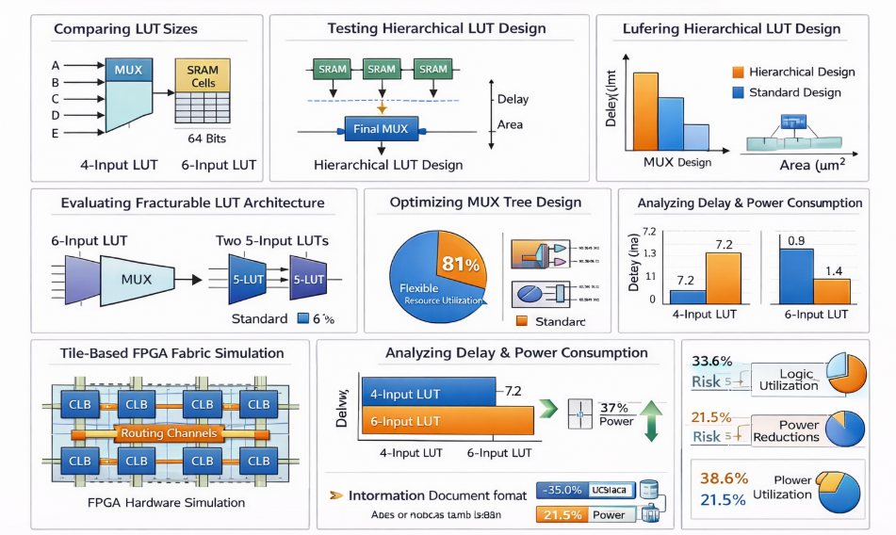

RESULTS
- The proposed scalable SRAM-based LUT architecture for high-density FPGA fabric is evaluated based on performance metrics such as delay, power consumption, area utilization, and logic efficiency. The results are obtained through simulation of different LUT configurations and architectural techniques.
- Firstly, the performance of different LUT sizes such as 4-LUT and 6-LUT is compared. It is observed that the 6-LUT reduces the number of logic levels required for implementation, thereby improving overall speed. However, it consumes slightly more area compared to 4-LUT. Thus, a trade-off between area and speed is identified.
- Secondly, the hierarchical LUT design is analyzed. The results show that combining smaller LUTs reduces propagation delay and improves scalability. Compared to a single large LUT, the hierarchical approach provides better performance and efficient resource utilization.
- Further, the fracturable LUT architecture demonstrates significant improvement in logic utilization. A single 6-LUT configured as two smaller LUTs allows multiple logic functions to be implemented simultaneously. This reduces unused resources and increases efficiency in FPGA fabric.
- The MUX tree optimization results indicate that an optimized multiplexer structure reduces signal delay and switching activity. This leads to faster output generation and lower dynamic power consumption.
- At the system level, the tile-based FPGA architecture is evaluated. The arrangement of LUTs into Configurable Logic Blocks (CLBs) and the use of efficient routing strategies improve overall performance. Local routing provides faster communication within blocks, while global routing ensures connectivity across the FPGA.
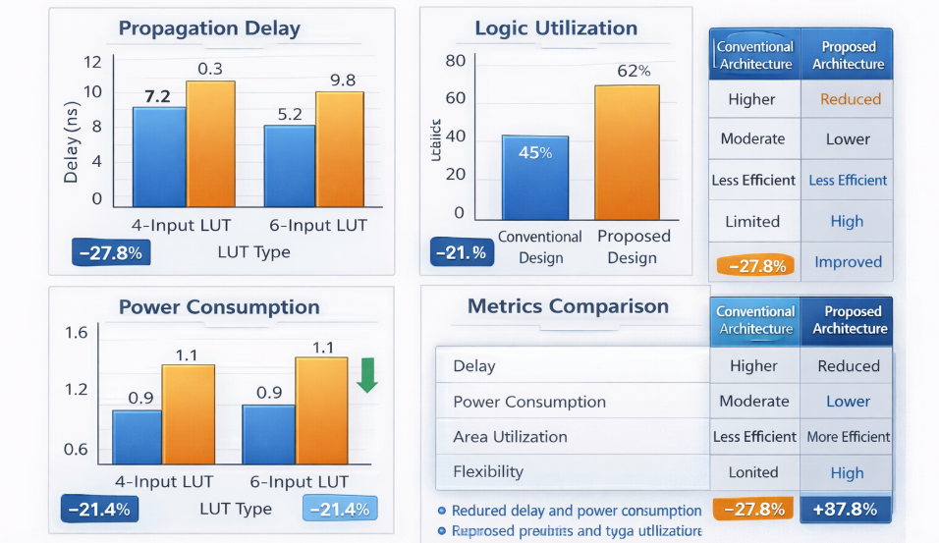

CONCLUSION and FUTURE WORK
[For Examples]

In this project, a scalable SRAM-based Look-Up Table (LUT) architecture for high-density FPGA fabric has been successfully designed and analyzed. The proposed architecture focuses on improving performance, flexibility, and resource utilization compared to conventional LUT designs. By using SRAM cells for storing logic functions and optimized multiplexer structures for output selection, the design ensures efficient implementation of combinational logic.
The incorporation of hierarchical LUT design significantly reduces propagation delay and improves scalability, while the fracturable LUT architecture enhances logic utilization by allowing a single LUT to perform multiple functions. Additionally, the use of an optimized MUX tree structure contributes to faster signal selection and reduced power consumption. The implementation of a tile-based FPGA architecture with efficient routing mechanisms further improves overall system performance.
- Future Work
Although the proposed architecture demonstrates significant improvements, there are several areas for further enhancement:
- Implementation of low-power techniques such as power gating and dynamic voltage scaling to further reduce energy consumption
- Exploration of advanced SRAM cell designs to improve stability and reduce leakage power
- Development of adaptive LUT architectures that dynamically adjust size based on application requirements
- Integration with advanced FPGA routing algorithms to further optimize interconnect performance
- Hardware implementation on real FPGA platforms (such as Xilinx/Intel FPGA boards) for practical validation

References
- [1] S. Brown and J. Rose, “FPGA and CPLD Architectures: A Tutorial,” IEEE Design & Test of Computers, vol. 13, no. 2, pp. 42–57, 1996.
- [2] I. Kuon and J. Rose, “Measuring the Gap Between FPGAs and ASICs,” IEEE Transactions on Computer-Aided Design of Integrated Circuits and Systems, vol. 26, no. 2, pp. 203–215, 2007.
- [3] S. Trimberger, Field-Programmable Gate Array Technology, Springer, 1994.
- [4] Xilinx Inc., “7 Series FPGAs Configurable Logic Block User Guide (UG474),” 2016.
- [5] Altera (Intel FPGA), “Stratix V Device Handbook,” Intel Corporation, 2018.
- [6] R. Tessier and W. Burleson, “Reconfigurable Computing for Digital Signal Processing: A Survey,” Journal of VLSI Signal Processing, vol. 28, pp. 7–27, 2001.

